اﻹسﻼمॽة

الʲقافة

ʜؗʛم

ʗʴت

العॽȃʛة

Ǽالؔلॽة

الʢلॼة

zॽãʲت

ةॽɻʺج

**THASQEEFU THWALABA ASSOCIATION**

**Markazu Ssaqafathil Islamiyya Arabic College, Kundoor**

P.O. Nannambra – 676320, Malappuram Dist., Kerala, Ph : 0464 2480712

Mob : +91 9746675758 Email : [thasqeefmedia@gmail.com](mailto:thasqeefmedia@gmail.com)

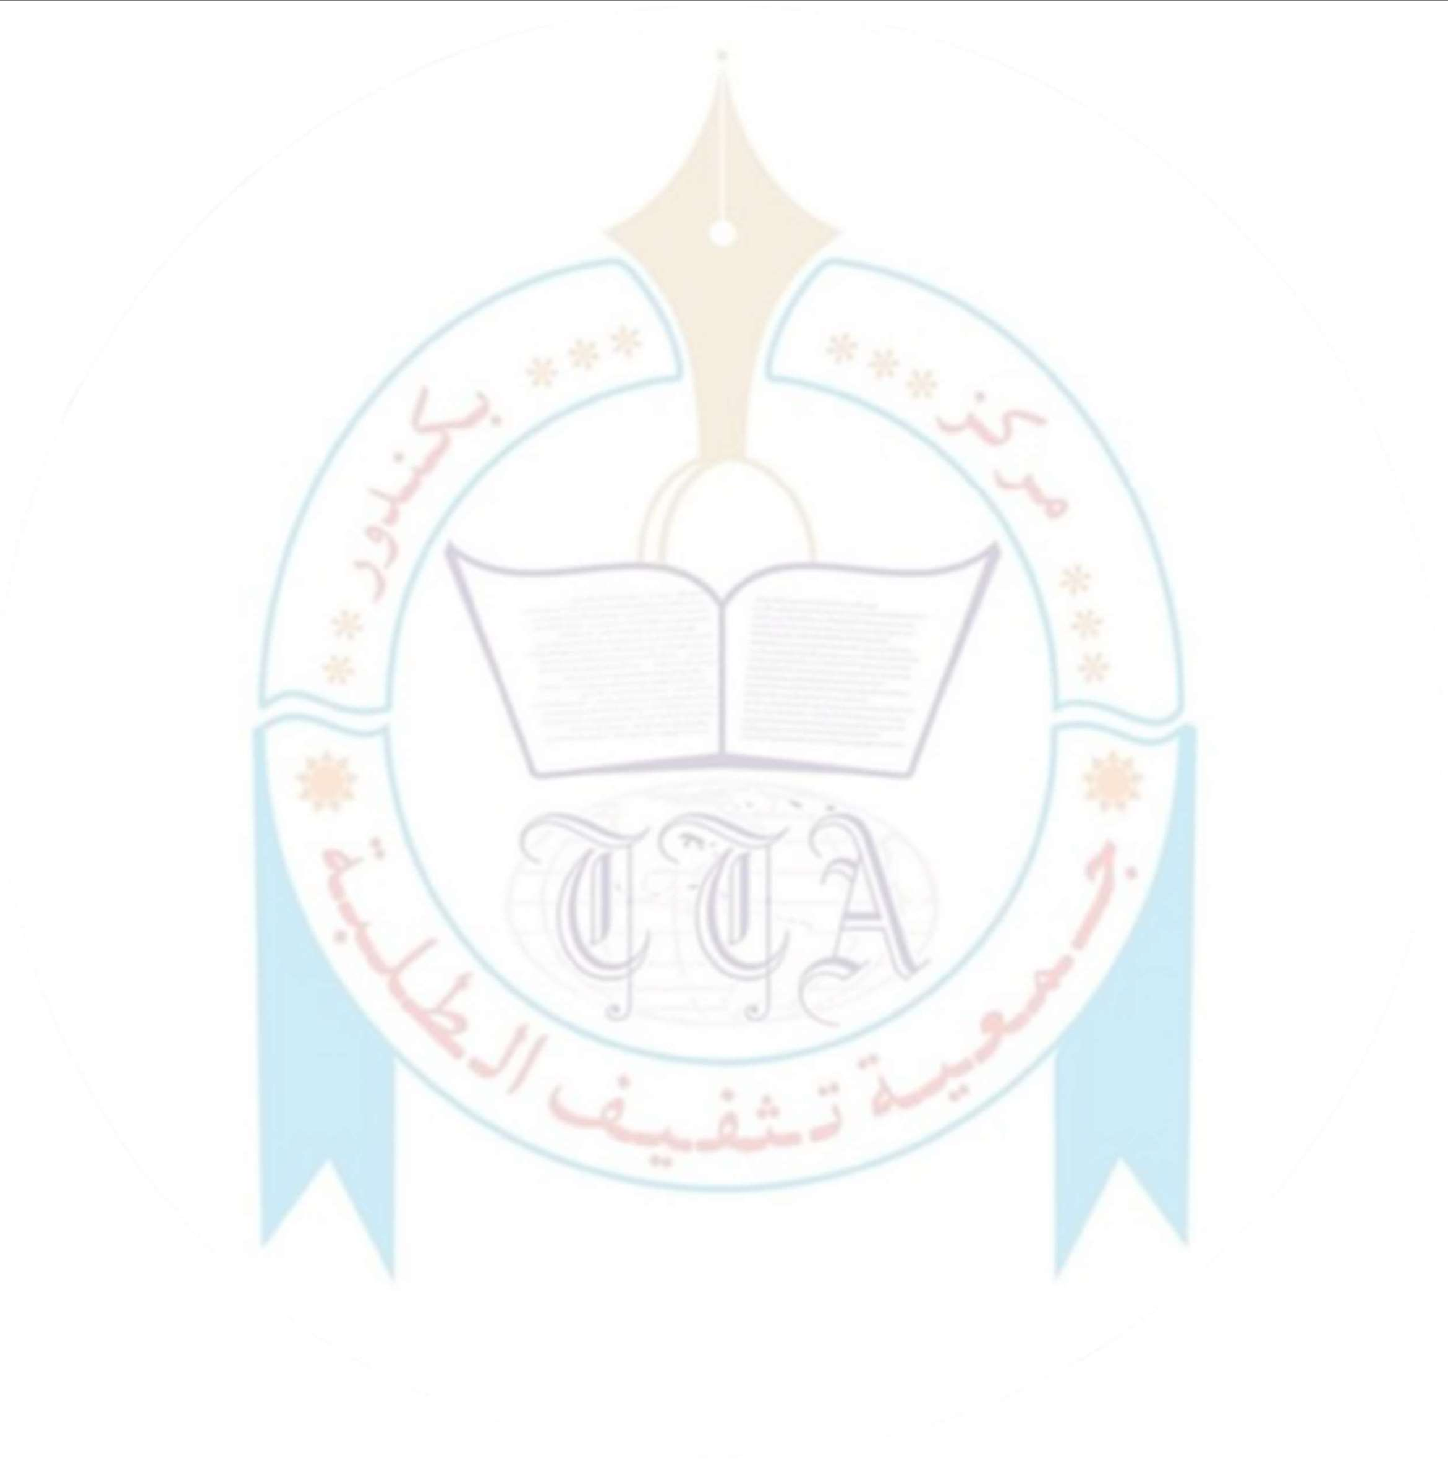

*Ref Date* 06/08/2024

D3aí,

W3 aí3 »l3as3a io ;omi;ai3 ik3 ollowi;g siua3;is íom ouí i;siiiuiio; io »aíiici»ai3 i; ik3 Nuaoomul Quí'a; 2025 – 6ll K3íala Hi z Com»3iiiio;:

1. Mukamm3a Hiskam
2. Mukamm3a Skam33l
3. 6slam Mukyuak33;

I k3í3»y co; iím ikai ik3 a»ov3-m3;iio;3a siua3;is aí3 cuíí3;ily siuayi;g ai ouí i;siiiuiio;.

Píi;ci»al's Sig;aiuí3: S3al:

Dai3: